

Information Processing Letters 90 (2004) 73–80

www.elsevier.com/locate/ipl

Packet loss probability for DiffServ over IP and MPLS reliable
homogeneous multicast networks ✩

Abdullah AlWehaibiª,∗, Michael Kadoch^{b}, Anjali Agarwalª, Ahmed ElHakeemª

a Department of Electrical and Computer Engineering, Concordia University, Montreal, Canada
b Department de Genie Electrique, Ecole de Technologie Supйrieure, Universitй du Quebec, Montreal, Canada
Received 9 May 2003
Communicated by F. Dehne

Abstract
Multicasting has become increasingly important with the emergence of Internet-based applications such as IP telephony,
audio/video conferencing, distributed databases and software upgrading. IP multicasting is an efﬁcient way to distribute
information from a single source to multiple destinations at different locations. In practice IP is considered as a layer 3 protocol.
Multiprotocol Label Switching (MPLS) replaces the IP forwarding by a simple label lookup. MPLS combines the ﬂexibility of
layer 3 routing and layer 2 switching.
In order to provide QoS in group communications for real time applications such as video conferencing, reliable multicasting
is used. Miscellaneous efforts have been undertaken to provide reliability on top of IP multicast. Two error control strategies
have been popular in practice. These are the FEC (Forward Error Correction) strategy, which uses error correction alone, and
the ARQ (Automatic Repeat Request) strategy, which uses error detection, combined with retransmission of data.
In this paper, we present a new fair share policy (FSP) that utilizes Differentiated Services to solve the problems of QoS and
congestion control when reliable ARQ multicast is used. The results should provide insight into the comparisons of the residual
packet loss probability between IP multicast in MPLS networks using FSP and plain IP multicasting using the same policy
when DiffServ are adopted and when reliable ARQ multicast is considered.
 2004 Elsevier B.V. All rights reserved.
Keywords: Interconnection networks; Packet loss; Multicast; IP; MPLS

1. Introduction

Multicasting has been at the center of interest in
the area of Internet activities and has already attained

✩ Work supported by NSERC/BELL Canada, Joint CRD grant
program.
* Corresponding author.
E-mail addresses: aa_alweh@ece.concordia.ca
(A. AlWehaibi), ahmed@ece.concordia.ca (A. ElHakeem).
0020-0190/$ – see front matter  2004 Elsevier B.V. All rights reserved.
doi:10.1016/j.ipl.2004.01.008

major successes. IP multicast supports group commu-
nications by enabling sources to send a single copy
of a message to multiple recipients at different loca-
tions who explicitly want to receive the information
[1]. With the huge increase demand for bandwidth, one
of the challenges the Internet is facing today is to boost
the packet forwarding performance.
Recent developments in Multiprotocol Label
Switching (MPLS) open new possibilities to address
some of the limitations of IP systems. MPLS is an In-

74

A. AlWehaibi et al. / Information Processing Letters 90 (2004) 73–80

ternet Engineering Task Force (IETF) standard [2]. It
replaces the IP forwarding by a simple label lookup
mechanism. MPLS combines the ﬂexibility of layer 3
(L3) routing and layer 2 (L2) switching, which en-
hances network performance in terms of scalability,
computational complexity, latency and control mes-
sage overhead. Besides this, MPLS offers a vehicle
for enhanced network services such as Quality of Ser-
vices (QoS)/Class of Service (CoS), Trafﬁc Engineer-
ing and Virtual Private Networks (VPNs). IP multicast
in MPLS networks is still an open issue [2–4].
On the other hand, the IETF DiffServ working
group is looking at a more scalable model and more
likely to be easier to implement than IntServ/RSVP
model [5]. In the DiffServ architecture, trafﬁc that re-
quires the same Per-Hop-Behavior (PHB) is aggre-
gated into a single queue. The DiffServ architecture
[6] focuses on the use of DiffServ (DS) byte, which
is the redeﬁned 8-bit Type of Service (TOS) ﬁeld in
the IPv4 header or the IPv6 Trafﬁc Class octet as a
QoS mechanism. Packets are classiﬁed into the cor-
responding queues using their DiffServ Code Points
(DSCP). Packets use DSCP bits in order to receive
a particular PHB, or forwarding treatment. Marking,
classiﬁcation, trafﬁc conditioning or policing are done
at network boundaries (ﬁrst router for example) and
packet treatment and handling is carried on each net-
work node [6].
Reliable multicasting is used to provide QoS in
group communications for real time multimedia ap-
plications such as video conferencing. Two main error
control strategies are well known. These are the FEC
(Forward Error Correction) strategy, which uses error
correction alone, and the ARQ (Automatic Repeat Re-
quest) strategy, which uses error detection, combined
with retransmission of repair data [7–9].
In ARQ strategy, when an error is detected at the
receiver, a request (NAK) is transmitted to the sender
to repeat the incorrect message, and this continues
until the message is received correctly. ARQ can
be divided into two types: stop-and-wait ARQ and
Continuous ARQ which can be further divided into
two subtypes: go-back-N ARQ and selective-repeat
ARQ. In our work, we will use selective repeat
ARQ. When reliable multicasting is used, there is a
scalability problem to accommodate arbitrarily large
groups of receivers where each receiver would be
sending an acknowledgment to the sender, which in

case of large group could easily result in feedback
implosion problem. This problem can be solved by
allowing the receivers to send NAKs only in case of
errors or lost data. There are two methods to send the
repair packets from the sender to the receiver or group
of receivers:

(1) Multicast repairs: In case of receiving a NAK
from one or more receivers the sender multicast
again the repair packet to all receivers.
(2) Unicast repairs: With unicast repairs, if the sender
received a NAK from one or more receivers, it
resends the repair packet to only the receivers who
did not receive the packet correctly in a unicast
manner.

The multicast repairs method is simpler than the uni-
cast repairs method and requires less overhead; how-
ever the multicast repairs methods consumes much
more bandwidth. In our work we will evaluate the per-
formance of the ARQ with multicast repairs only.
In this paper, we compare QoS performance of IP
and MPLS multicasting, given their particular con-
straints [10]. In regular IP multicasting only over-
head pertaining to IP multicast tree should be estab-
lished, while in MPLS multicasting we have to add
also the corresponding MPLS multicast tree establish-
ment times and control packets. We present a new fair
share policy and by taking the above constraints into
consideration, we evaluate the QoS performance in
terms of residual packet loss probability for a typical
binary tree in the two cases of IP and MPLS multi-
casting. We also consider Differentiated Services; i.e.,
trafﬁcs with different priority classes when reliable
ARQ multicast is used. Analysis tools will be used to
evaluate our fair share policy (FSP) for different ho-
mogeneous network scenarios.

2. The analytical model underlying Fair Share
Policy (FSP)

FSP is not a call admission rather it is a trafﬁc
policing mechanism. In FSP, packets are discarded in
case of congestion differently at each queue accord-
ing to source priority and the maximum number in the
queue; i.e., the source with higher priority will expe-
rience less packet discarding than sources with lower

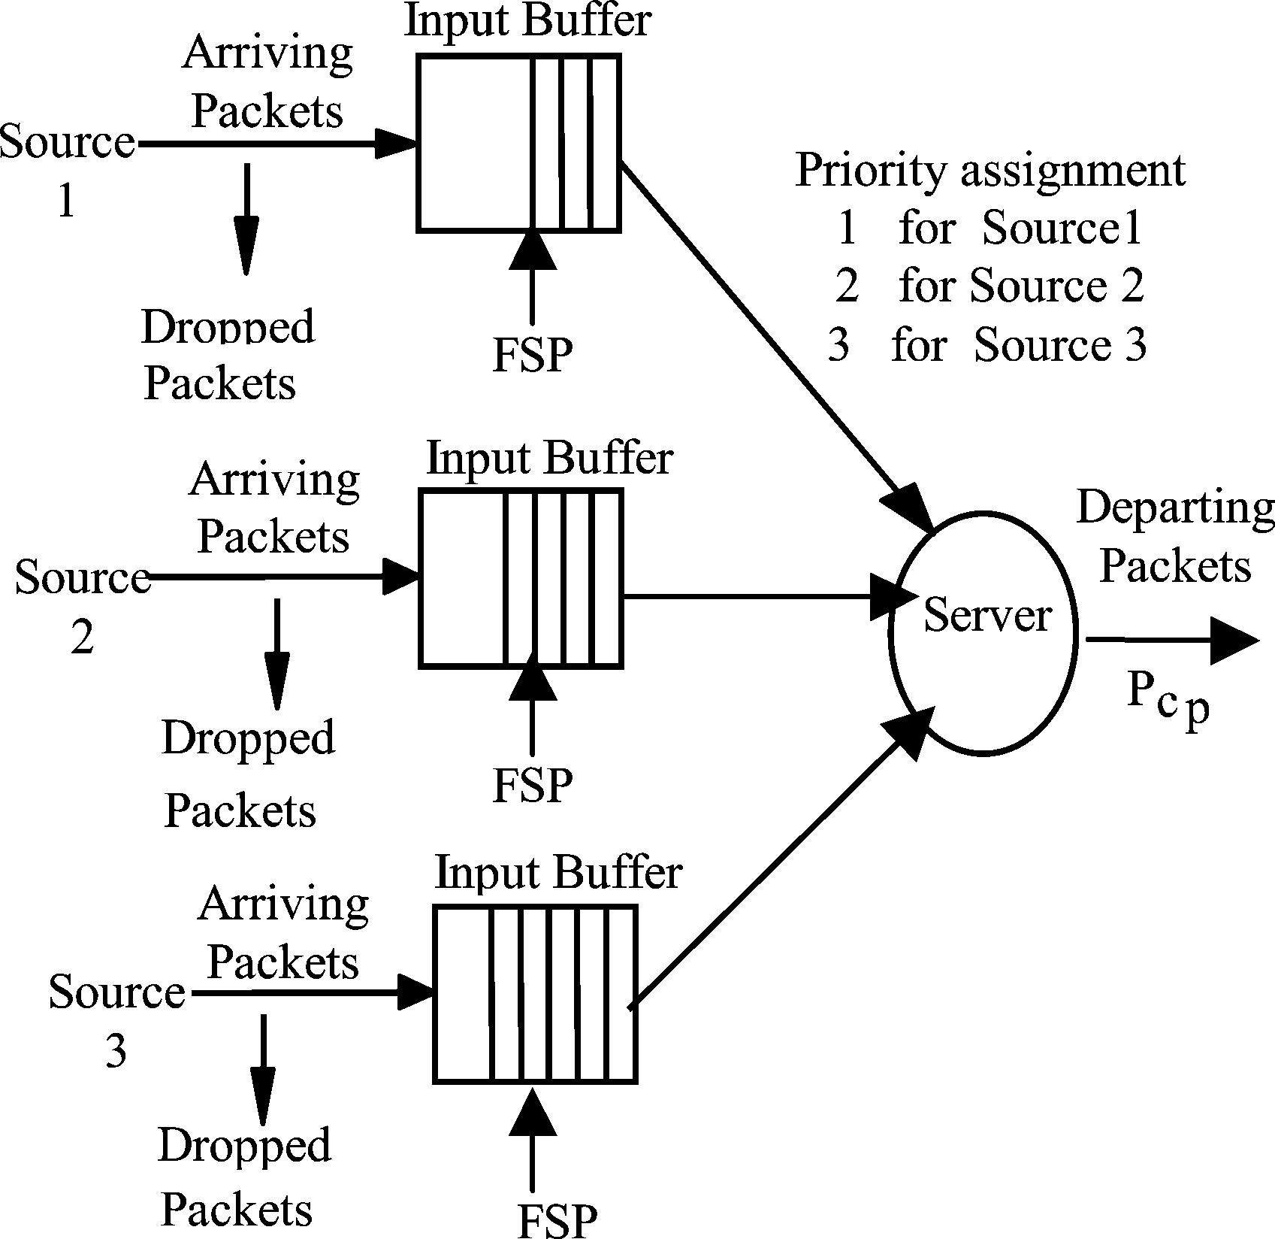
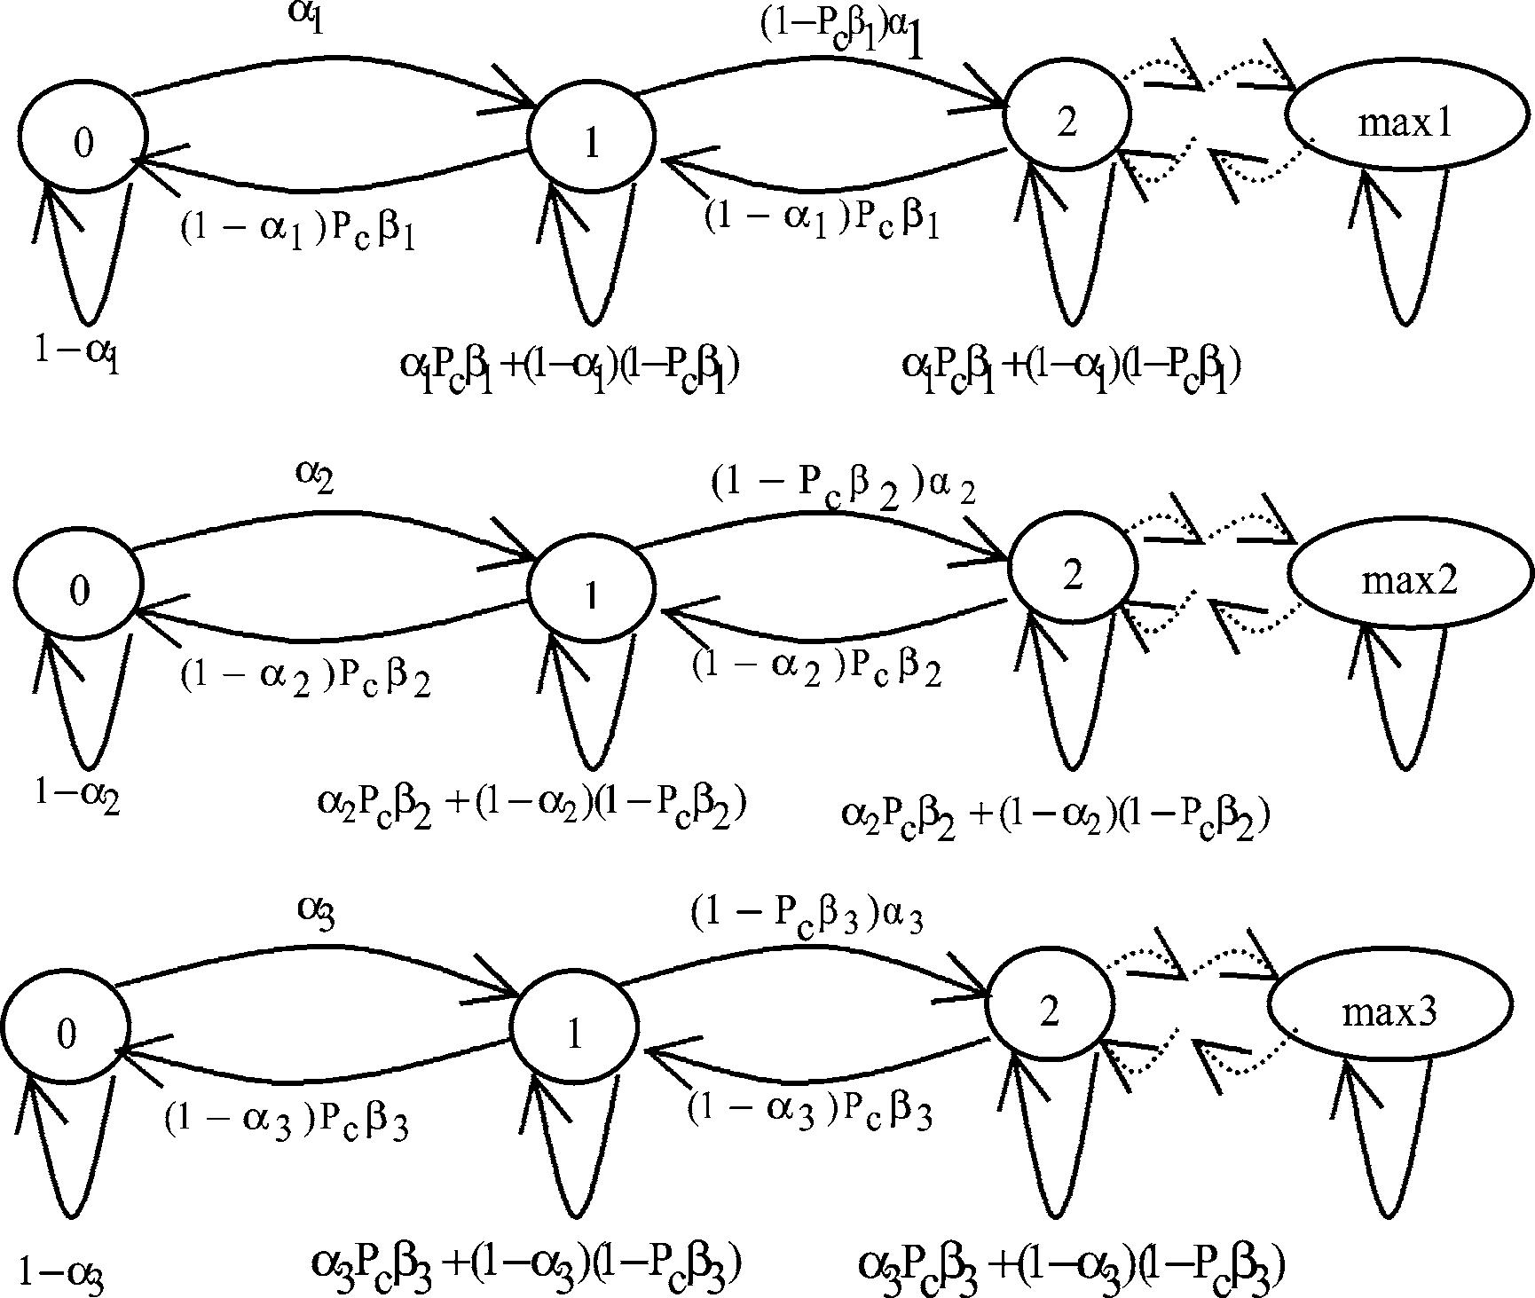

A. AlWehaibi et al. / Information Processing Letters 90 (2004) 73–80

Fig. 2. The coupled state diagrams.

75

Fig. 1. The analytical model.

where maxp, p = 1, 2, 3, is calculated as:
Pr

priorities. Moreover, FSP guarantees fairness among
ﬂows having the same priority (i.e., required QoS) in
maxp⁼∑^{p}
p^{Pr}p
∗ B,

buffer space allocated to lower priority trafﬁc is larger;
thus leading to less packet discard [10]. Our analytical
model is shown in Fig. 1. In this model, a typical IP
or MPLS router and our FSP trafﬁc policing mecha-
nism process three independent sources corresponding
to different input trafﬁc classes. Source 1 is assigned
the highest priority, then source 2 and ﬁnally source 3.
For this model, the enforcement is assumed to occur at
the router (node) according to Fair Share Policy.
The following assumptions are used:

(1) Assume a Bernoulli arrival for all sources; in
order to be short and discrete interarrivals.
(2) FSP uses non pre-emptive priority queuing.
(3) The arrival probabilities are α₁, α₂and α₃for
each source respectively. Note that α represents
the probability of receiving a packet while one
packet is served on the channel.
(4) Service disciplines for different queues are β₁,
β₂and β₃for each source respectively.
(5) Average queue sizes are E1(n), E2(n) and E3(n)
for each source respectively.
(6) Maximum buffer sizes are max1, max2 and max3
for each source respectively.
(7) Total system buffer size:
B = max1⁺max2⁺max3,
where Pr_{p}is source p priority.
(8) All of MPLS or IP routers on the subject Inter-
net are homogeneous in providing resource and
trafﬁc conditions.
(9) All packets are of the same length.
(10) Steady state conditions prevail such that the
distribution of the number of packets in the
queue will not change with time and hence E₁(n)
for source 1 for example will be taken as a
representative ﬁgure of the actual number in the
queue n₁.

The coupled state diagrams for the analytical model
in Fig. 1 are shown in Fig. 2.
This diagram represents a typical router with 3
priority classes. The solution of the number in every
class depends on the solutions of the other classes;
where β₁= 1 always in order to give source 1 with
highest priority the best service probability, β₂= P₀1;
i.e., packets from source 2 will be served only when
the buffer corresponding to source 1 (which has higher
priority) is empty and ﬁnally β3⁼P₀1_{P}0²; i.e., packets
from source 3 will be served only when the buffers
corresponding to source 1 and source 2 (which have
higher priority) are all empty. Pc_{p}is the probability of
successful delivery to next router for priority p trafﬁc
(p = 1, 2, 3).

76

A. AlWehaibi et al. / Information Processing Letters 90 (2004) 73–80

1 − σ λ

Packet loss probability for each source can be
obtained by calculating the probability to be in last
Pn⁼
µ
P_{n}−1 −
µ
P_{n}−2

stage in the state diagram P_{max}1,P_{max}2^{and}P_{max}3
respectively.
For IP based networks, the source arrival probabil-
for n = 3, 4, . . . , max_{p}.
Eq. (8) can be rewritten as:
1 − σ λ
(8)

ity α is actually a composite one; for instance α₁(for
source 1) can be written as:
P_{n}+2⁼
µ
P_{n}+1 −
µ
P_{n}

α₁= τ α₁1₊α₁2,τ =
∆₁+ ∆₂
∆₁

,

(1)
for n = 3, 4, . . . , max_{p}.
Deﬁne m = (1 − σ )/µ and q = λ/µ.
(9)

where ∆₁is the processing time at lower layers (for
example MAC layer), ∆₂is the processing time at
Eq. (9) is the 2nd order homogeneous difference
equation [13], which has the general form:

IP layer and τ is the IP processing time factor (or
processing factor).
P_{n}+2⁺2aP_{n}+1⁺bP_{n}= 0,
(10)

α¹2
1 is the intrinsic arrival probability, α₁is the extra
arrival probability due to IP control overhead used to
where a = −m/2 and b = q , the general solution of
Eq. (10) is of the form [13]:

establish the IP multicast tree. The above equation can
be rewritten in terms of α¹1^{as:}
Pn⁼Ar₁n₊Br₂n,
(11)

α₁= τ α₁1 + ξ₁α₁1,ξ₁=
α2
1
α¹

,

(2)
where r1 and r2 are the distinct roots of the Eq. (10);
A and B are constants. The characteristic equation of
Eq. (10) is:

1
where ξ₁is the IP control overhead factor (or IP
factor).
r²− mr + q = 0
which has the solution:
(12)

Similarly for MPLS based networks, α₁can be
written as:
α₁= α₁1₊α₁2₊α₁3,(3)

r₁=
m +
Ⲛ
m2 − 4q
2

,

r₂=
m −
Ⲛ
m2 − 4q
2

.

where α1
2
The initial conditions for the set of equations are P₁
and P₂. Using Eq. (11), we write:

1^{and}α₁are the same as in the case of IP
networks; α₁3 is the extra arrival probability due MPLS
control overhead used to establish MPLS multicast
paths or tree. α₁can be rewritten in terms of α¹1^{as:}
α3
α1⁼(1 + ξ1⁺ξ2)α₁1,ξ2⁼1,(4)
P₁= Ar₁+ Br₂= kP₀,
P₂= Ar₁2 + Br₂2 = ωP₀,
where
(
(13)
(14)

α¹
ω =
(1 − σ )α
− α
and k =
α
.

1
where ξ₂is the MPLS control overhead factor (or
µ2
µ
µ

MPLS factor).
By writing the balance equations for the state
diagrams in Fig. 2 [11,12], and solving these equations
Substituting for r₁and r₂and solving Eqs. (13)
and (14) together to ﬁnd A and B, we obtain:
( (

to ﬁnd the probabilities. In order to write the equations
B =
ω − kr1
r²
2 − r₁r₂
P₀and A =
ωP₀− Br₂2
r²
.

in simpler forms we deﬁne:
λ = (1 − Pcβ)α, µ = (1 − α)Pcβ,
1
In order to ﬁnd nth probability P_{n}, our solution for
Eq. (11) can be written as:

σ = αP_{c}β + (1 − α)(1 − P_{c}β),
α
P₁= P₀,
(5)
(6)

Pn⁼
(
ωP₀− Br₂2
r²
(
m +
Ⲛ
m2 − 4q
2
n

P2⁼
µ
1 − σ
µ

P₁−
α
µ

P₀=
[
(1 − 6)α − α
µ2 µ
]
P0, (7)

+
(
1
ω − kr₁
r²
2 − r1r2

P
(
0
m −
Ⲛ
m2 − 4q
2
n

. (15)

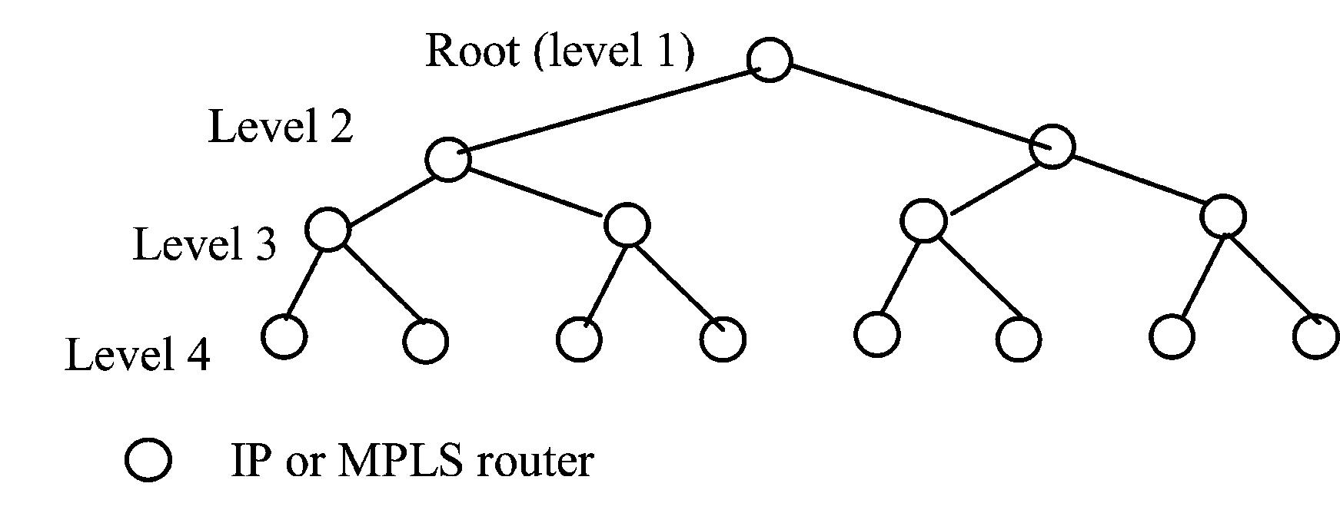

A. AlWehaibi et al. / Information Processing Letters 90 (2004) 73–80
∑_{max}p

77

Taking into account that
n=0^{P}n⁼1, P₀can be
are the routers with receivers underneath them. As

found using the following equation:
1
P₀= ∑_{max}p
shown in the ﬁgure the depth of this tree is 4 and the
total number of routers is 15.

=
1 +
n=1^{P}n

1

max

max

3. Reliable ARQ multicast repairs

1 + k + ω + Ar₁3₊Br₂3 + · · · + Ar
p
p

=

1 + k + ω + Ar1
1
1
rmaxp−2
1
1−r1⁺Br2
1⁺Br₂
. (16)
-261
rmaxp−2
2
1−r2
Pcp which is the probability of successful delivery
to next router for certain priority trafﬁc, would be
given as:

Therefore, the solution of probability of steady state
of the number of packets in the buffer is now given by
Pcp⁼(1 − Pop − Pep )^{L}, p = 1, 2, 3.
(19)

Eq. (15). The expected number of packets in the buffer
for a speciﬁc source p can be found as:
max∑^{p}
Ep (n) = n ∗ Pn
n=0
= 1 ∗ k ∗ P₀+ 2 ∗ ω ∗ P₀
max∑^{p}( n
+ n ∗ Ar^{n}(17)
1⁺Br₂.
n=3
Notice that the packet loss probability for source p is
equal to the probability to be in last stage of the state
diagram:
Po_{p}is the byte overﬂow for a certain priority trafﬁc
which can be obtained by dividing the packet overﬂow
probability in Eq. (18) by packet length (L). Pe_{p}is the
byte error probability for a certain priority trafﬁc p and
it is assumed to be equal to Po_{p}.
In Eq. (19), two assumptions are made:

(1) Packet loss of source packet is caused by consec-
utive byte losses at the intermediate routers.
(2) Interleaving is used in order to break byte burst
losses and efﬁciently turn them independent ran-
dom byte losses at the source and destination [9].

PLp⁼Pmax_{p}(p = 1, 2, 3).
(18)
Probability of no packet loss for certain priority trafﬁc
is given by:

The same solution above applies to state diagrams in
Figs. 2(middle) and 2(bottom) as well except that in
Fig. 2(middle) α = α2, β = β2 and max = max2 and
that in Fig. 2(bottom) α = α3, β = β3 and max =
max3.
One more assumption is added for reliable multi-
cast that we use a complete binary tree, where each
parent router has two children routers until we reach
leafs. Fig. 3 shows an example of a complete binary
tree with the root, which is the nearest router to the
sender or the rendezvous point, and the leafs, which

Pno packet loss_{p}= (1 − Pop)^{L}
∼₁− LPop
for small values of Po_{p}, p = 1, 2, 3.
Therefore, probability of packet loss for small values
of Po_{p}and for certain priority trafﬁc p can be
expressed as:
Ppacket loss_{p}= 1 − Pno packet loss_{p}= LPo_{p},
Ppacket loss_{p}

Pop⁼
L
, p = 1, 2, 3.

Fig. 3. A complete homogeneous binary multicast tree.
In this case upon the receipt of a NAK from
one or more receivers, the sender multicast again the
repair packet to all receivers. Due to the use of ARQ
multicast repairs, the intrinsic arrival probability α_{p}1
for certain priority trafﬁc p would increase according
to:
α¹p⁼α_{p}1₍1 + Fp ), p = 1, 2, 3. (20)

78

A. AlWehaibi et al. / Information Processing Letters 90 (2004) 73–80

Fp is the number of failures for certain priority trafﬁc
p and N is the total number of routers in the multicast
tree. This increase in the intrinsic arrival probability is
due to that every router in the whole network receives a
copy of each repair packet. The Probability of success
for worst case scenario for certain priority trafﬁc p is
given as:

The total number of ARQ trials Tp for speciﬁc
priority trafﬁc p can be expressed as:
Tp⁼Psp⁺2Psp(1 − Psp) + 3Psp(1 − Psp)²+ · · · .
(23)
Therefore, the number of failures (or retransmissions
only) for certain priority trafﬁc p can be given as:

Pspw = Probability of success
Fp⁼Tp − 1,
(24)

= Pc^{N}p worst case.
(21)
where Ps_{p}is the average probability of packet success

Eq. (21) represents an upper bound for worst case sce-
nario of probability of success when ARQ multicast
repairs method is used. However, using ARQ multi-
cast repairs have a better chance of success with each
trial since the number of receivers who did not receive
for priority p trafﬁc corresponding to one ARQ trial.
Deﬁning Ps_{p}as the ﬁnal probability of success for
priority p trafﬁc:
Ps_{p}= Psp⁺(1 − Psp)Psp + · · · + Psp(1 − Psp)^{T}p−1

the packet correctly decreases with each trial. There-
fore, the average probability of success for a certain
= 1 − (1 − Ps_{p})^{T}p.
(25)

priority p packet in a typical transmission multicast
trial from sender can be calculated as:
PcN_{p}+ Pc^{(N/}p²)+1 + · · · + Pc^{(N/}p²D₎+D−1
Eq. (25) is for (Tp) trials of a typical packet to the
multicast tree; Where we note that for one trial Ps_{p}=
Psp and for inﬁnite retransmission trials Psp⁼1 as it
should be. Therefore, the residual loss (after all ARQ

Psp avg =
D
,
(22)
trials) is given by:
Plossp⁼1 − Ps_{p}.

(26)

where D is the network depth. If the packet does not
suffer loss or error on any of the N routers of the
multicast tree, with probability Pc^{N}p no further repair
is needed, this explains the ﬁrst term of Eq. (22).
However, if there has been an error or loss which
located at level 1 (see Fig. 3), then the repair packet,
then the repair packet would be sent from sender to
the router at level 1, and then the repair packet will
ﬂow to N/2 routers under level 1. All such (N/2) +
1 transmissions of repair packet have to be correct,
otherwise further repair is needed and so on. The
probability of these (N/2) + 1 correct transmissions
of subject repair packet is given Pc^{(N/}p²)+1 and so on
for the remaining terms in Eq. (22).
We divide by D (network depth) because we
assume that errors are equally likely to occur on
different levels of the tree giving rise to the addition
of different terms (Eq. (22)) and the division by the
depth D where: D = log₂(N + 1).
A more accurate expression for Psp was evaluated
in [14]. However, results of [14] shows that of Eq. (22)
is very close to the exact value over a wide range of
Pcp and N .

4. Analysis results

Figs. 4 to 6 show the performance comparisons be-
tween IP sources and MPLS sources in the multicast
tree when ARQ multicast repairs mechanism is ap-
plied. Fig. 4 shows the residual packet loss probability
for all sources for both IP and MPLS versus IP fac-
tor (ξ₁) for small processing factor (τ ). It shows that
IP and MPLS sources have very same residual packet
loss probability (almost zero).
However, Fig. 5 shows that when the processing
factor (τ ) increases MPLS will have superiority over
IP in terms of the residual packet loss probability. As
shown in Fig. 5 the residual packet loss probability
in case of MPLS (which is zero) is less than IP for
all sources and this difference is clear for low priority
sources 2 and 3.
In Figs. 4 and 5 MPLS factor was constant and
relatively small; explaining why MPLS performance
was better or very similar to IP performance. However,
in the following ﬁgure we will study the effect of
MPLS factor (ξ2) on MPLS performance. Fig. 6 shows

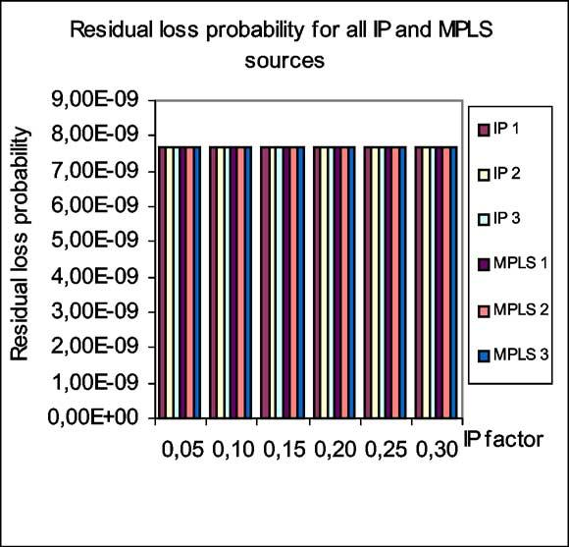
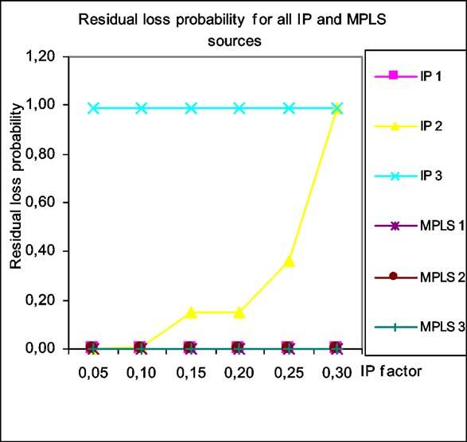
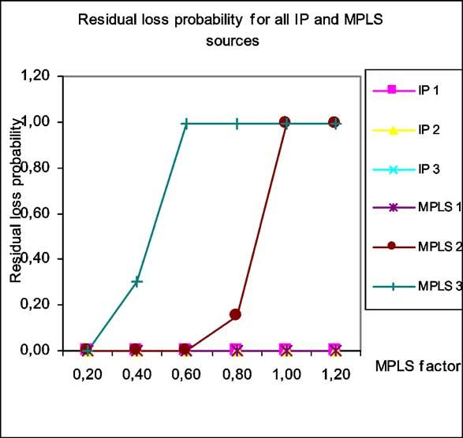

2

3

A. AlWehaibi et al. / Information Processing Letters 90 (2004) 73–80

3
2

79

α¹1⁼0.2, α₁= 0.15, α₁= 0.1, β1⁼1, Tp⁼2, D = 4,
B = 30, ξ2⁼0.1, τ = 1.2, L = 500
Fig. 4. Residual loss probability versus IP factor (small τ ).

3
2
α¹1⁼0.25, α₁= 0.2, α₁= 0.15, β1⁼1, Tp⁼2, D = 4,
B = 30, ξ2⁼0.1, τ = 1.8, L = 500
Fig. 5. Residual loss probability versus IP factor (large τ ).

that IP will be superior over MPLS when MPLS factor
increases. As shown in Fig. 6 the residual packet loss
probability in the case of IP (which is zero) is less
than MPLS for all sources and this difference is clear
for low priority sources 2 and 3. This means when

α¹
1⁼0.2, α₁= 0.15, α₁= 0.10, β1⁼1, Tp⁼2, D = 4,
B = 30, ξ1⁼0.2, τ = 1.2, L = 500
Fig. 6. Residual loss probability versus MPLS factor.

the extra arrival rate due MPLS control overhead used
to establish MPLS multicast paths or tree increases,
IP will be perform better especially for low priority
trafﬁcs and when the intrinsic trafﬁcs increase.

5. Conclusions and future work

In this paper, a performance comparison between
IP multicast trees and MPLS multicast trees is car-
ried using analysis tools. In addition to that a new
Fair Share Policy (FSP), which is a trafﬁc policing
mechanism, is proposed to ensure proper QoS. Also,
Differentiated Services and ARQ reliable multicasting
are used in this comparison. In this paper, we found
that when the difference in packet processing time (τ )
between IP and MPLS is high and when MPLS fac-
tor is small, IP multicast will perform less efﬁciently
than MPLS in terms of residual packet loss probabil-
ity. However, when this difference in packet process-
ing time is small IP performs very similar to MPLS.
In addition to that when MPLS has higher arrival rate
due to MPLS trees establishment control overhead and
when the processing factor is small, IP would perform
better than MPLS.

80

A. AlWehaibi et al. / Information Processing Letters 90 (2004) 73–80

Analysis results revealed that there is a notice- [2] E. Rosen, A. Viswanathan, R. Gallon, Multiprotocol label

able improvement in QoS deﬁned as the residual
packet loss probability for a higher priority trafﬁc
when MPLS multicasting replaces IP multicasting es-
pecially if MPLS factor is small and processing factor
is large.
In addition to that, the study ﬁnds that when
applying the ARQ multicast repairs mechanism, there
would be a noticeable improvement in terms of the
residual packet loss probability which enhances the
reliability of multicasting for both IP and MPLS trees.
The routers in the network could be identical in
their capabilities (homogeneous network) or different
(heterogeneous network).
Each router may have different capabilities; for ex-
ample one router could have the ability to correct er-
rors (FEC) and use ARQ, one may use only ARQ but
cannot correct errors, a third one may not have MPLS
capability. In this paper, the study carried only homo-
geneous networks. In the near future, heterogeneous
networks would be considered.

References

[1] B. Quinn, et al., IP multicast applications: challenges and so-
lutions, RFC 3170, 2001, http://www.ietf.org/rfc/rfc3170.txt.
switching architecture, RFC 3031, 2001, http://www.ietf.org/
rfc/rfc3031.txt.
[3] D. Ooms, et al., Framework for IP multicast in MPLS, IETF
Draft, draft-ietf-mpls-multicast-07.txt, 2002.
[4] D. Ooms, W. Livens, IP multicast in MPLS networks, in:
Proceedings of the IEEE Conference on High Performance
Switching and Routing, 2000, pp. 301–305.
[5] J. Wrocklawski, The use of RSVP with IETF integrated
services, RFC 2210, 1997, http://www.ietf.org/rfc/rfc2210.txt.
[6] M. Carlson, et al., An architecture for differentiated services,
RFC 2475, 1998, http://www.ietf.org/rfc/rfc2475.txt.
[7] S. Lin, D. Costello, Error Control Coding: Fundamentals and
Applications, Prentice-Hall, Englewood Cliffs, NJ, 1983.
[8] B. Li, Reliable multicast transmissions using forward error
correction and automatic retransmission requests, in: Canadian
Conference on Electrical and Computer Engineering, 2001,
vol. 2, 2001, pp. 1145–1150.
[9] S. Wicker, Error Control Strategies—for Digital Communica-
tion and Storage, Prentice-Hall, Englewood Cliffs, NJ, 1995.
[10] A. AlWehaibi, A. Agarwal, M. Kadoch, A. ElHakeem, Perfor-
mance comparison between MPLS multicast and IP multicast
using fair share policy and priority buffers, in: IASTED CSN
2002, Spain, 2002.
[11] T. Saadawi, M. Ammar, A. Elhakeem, Fundamentals of
Telecommunication Networks, Wiley, New York, 1994.
[12] L. Kleinrock, Queuing Systems, vols. I and II, Wiley, New
York, 1975.
[13] D. Jordan, P. Smith, Mathematical Techniques, Oxford Univer-
sity Press, Oxford, 1994.
[14] A. AlWehaibi, M. Kadoch, A. ElHakeem, Computation of
the residual packet loss probability in a binary multicast tree,
in: IEEE Canadian Conference on Electrical and Computer
Engineering, CCECE 03, Montreal, Canada, 2003.

